

2.8 Input Command Walkthrough

In this walkthrough, we are going to be looking at how we can get information from the user and make use of it within our programs. We are going to start by getting text, then look at how we can get other data such as numbers. This project is going to build on where we left off during today’s earlier session, so that rather than having the name “hard-coded” into the program, it will get the user to enter the information.

Your Python program should look as follows (this has been slightly adapted so that there is a comma rather than +, but the + will work as well):

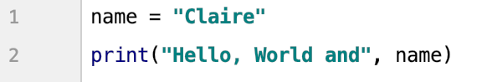

We are going to adapt the variable declaration for name so that it uses the input() command. The general structure of the input() command is:

input(“<<user prompt>>”)

Where the <<user prompt>> is instructions to the user detailing what you want them to enter. For this program, we are going to change the name declaration to:

name = input("Please enter your name: ")

Your code should now look as follows:

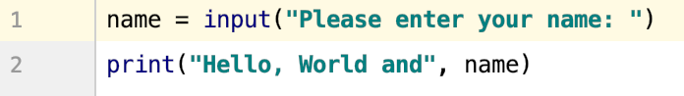

Now, when you run the program, you should get a prompt in the console window. The program will not continue until you have entered your name (in this case) and pressed enter:



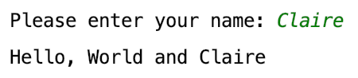

You have now written your first Python program which makes use of user input.

**Activity 1**

Adapt your program so that it also asks the user what their favourite subject at school / university is. Their input should be printed to the screen afterwards.

We are now going to look at another example, where we are going to get the user to enter two numbers, then add them together. Enter the following code:

num_a = input("Please enter your first number: ")

num_b = input("Please enter your second number: ")

num_c = num_a + num_b

print("The sum is:", num_c)

Your code should look as follows:

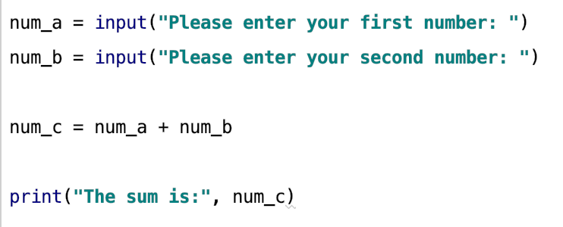

When we run the program, with the numbers 2 and 4, we would expect the answer to be 6 (as 2 + 4 = 6). However, this is not the case:

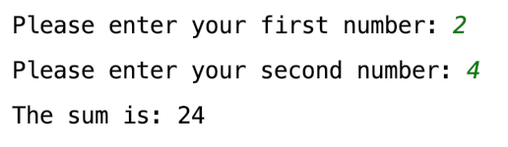

The next activity will encourage you to establish what the problem is and how you can resolve this issue.

**Activity 2**

You will notice that the calculator isn’t producing the answer we would expect. How can we overcome this? Do some research to see what the problem is and how you can resolve it.